
Advanced Information Sheet
ISBN 9781918204025
PRICE £15.00
PUBLICATION DATE 21 May 2026
FORMAT Hardback
ILLUSTRATIONS None
EXTENT 304 pages
CATEGORY Fiction
BIC CATEGORY FB
SIZE (h x w) 198 x 129 mm
7.79 x 5.07 in
RIGHTS WORLD
Author Information
Neil Gunn is the author of more than 20 works of fiction and memoir. He was born in Dunbeath, Caithness and lived, worked, and wrote about life in the Highlands.
Alan Taylor is an author and journalist, former deputy and managing editor at The Scotsman and writer-at-large for the Sunday Herald. He lives in the Scottish Borders.
The Serpent
Neil M Gunn
Introduction by Alan Taylor

An old man living at the height of his powers of recall and memory tells the story of his life on the day of his death from the vantage point on a hill above the village where he was born.

Quietly narrated and yet raging with will and the passion of youth, this is a novel about fathers and sons, hope and hope’s death, and how we might live in the world before leaving it. In the company of such masterpieces as Seethaler’s A Whole Life and Tolstoy’s The Death of Ivan Ilyich

A wildly immersive story, The Serpent will grip the reader from the outset and is a provocative and an-putdownable study of what it is to be human.

- Handsome HB with embossed linen cover and stunning printed endpapers.
- Part of centenary celebration of Gunn’s work supported by major PR campaign.
- Newly commissioned introduction by prominent author and journalist Alan Taylor

One of the most important Scottish writers of the twentieth century ― TLS

Modern Scottish fiction reaches its highest peak in the novels of Neil M. Gunn... Like Hardy, and indeed Joyce... he transcends regionalism and acquires universality. ― The Scotsman

Neil Gunn has given us a wonderful body of work…the greatest achievement of its kind in modern Scottish literature ― Hugh MacDiarmid

A brilliant novelist – Lewis Grassic Gibbon

Related Titles
The Grey Coast HB ISBN 9781918204001
Blood Hunt HB ISBN 9781918204018

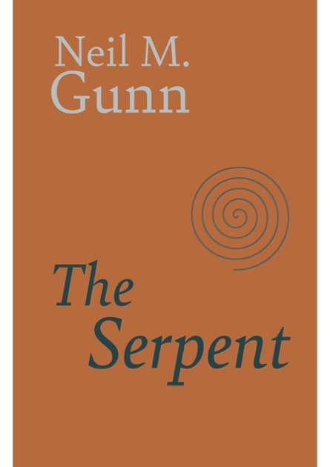

North House Press, The Grey House, Dalreavoch, IV28 3YF Telephone +44 (0)7768994332, Email: david@northhousepress.co.uk www. northhousepress.com

